1.

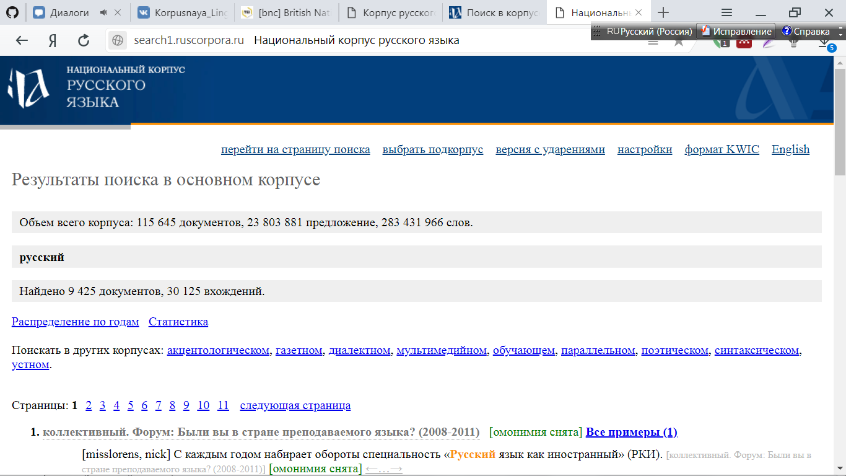

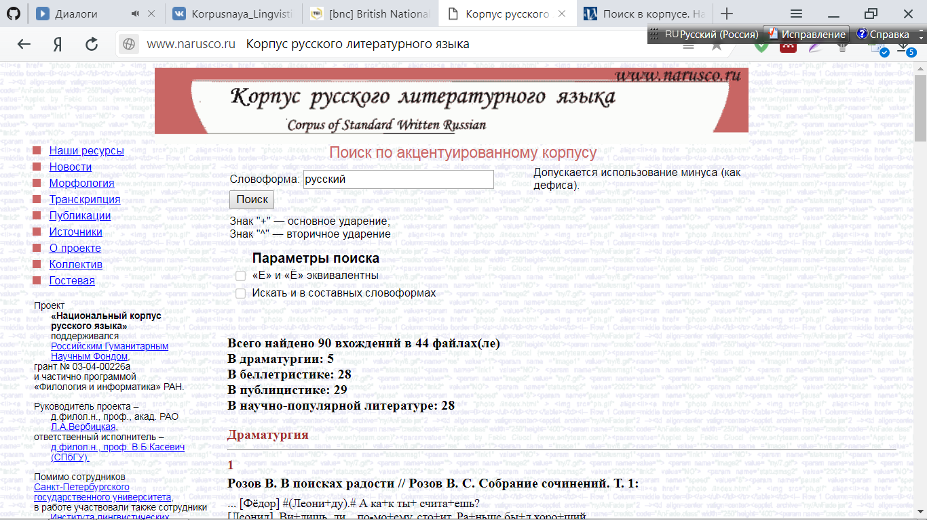

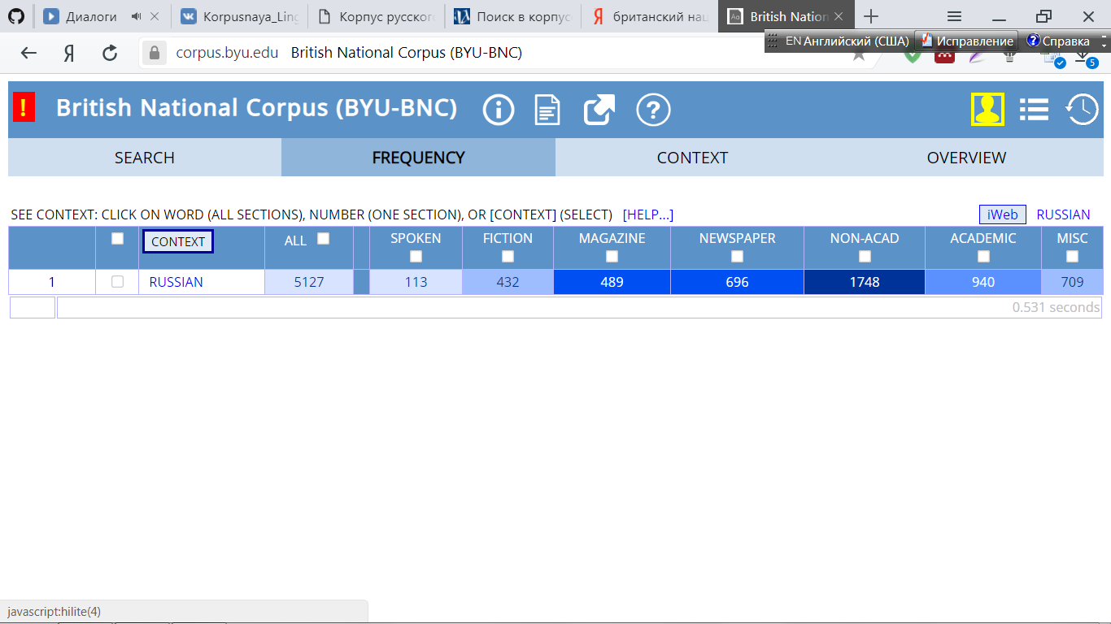

|  |  |  |  |
| --- | --- | --- | --- |
|  | НКР | КРЛЯ | БНК |
| Количество вхождений | 30125 | 90 | 5127 |
|  |  |  |  |

2.

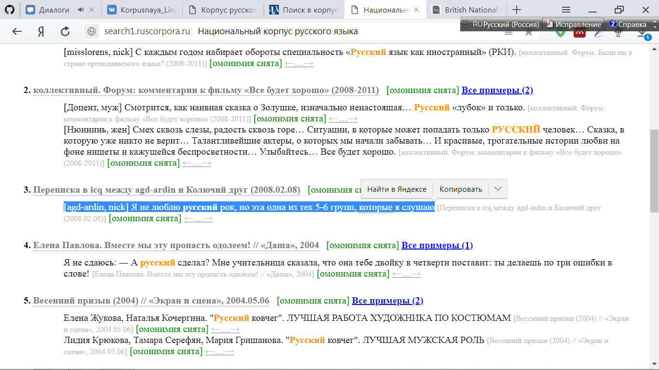

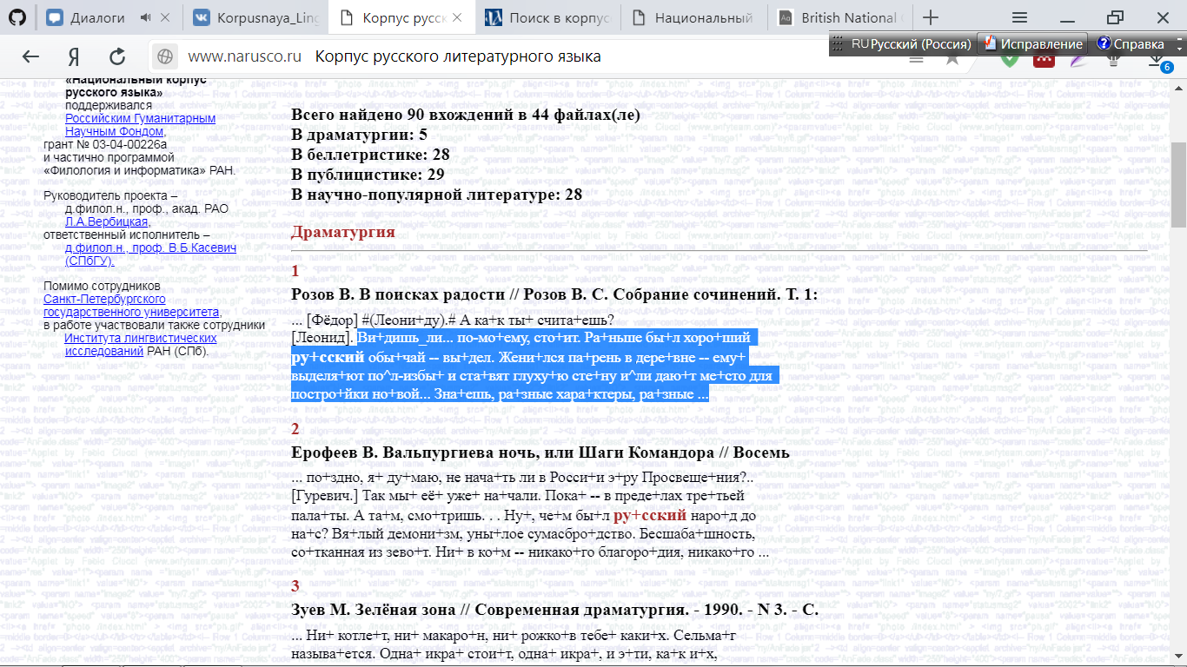

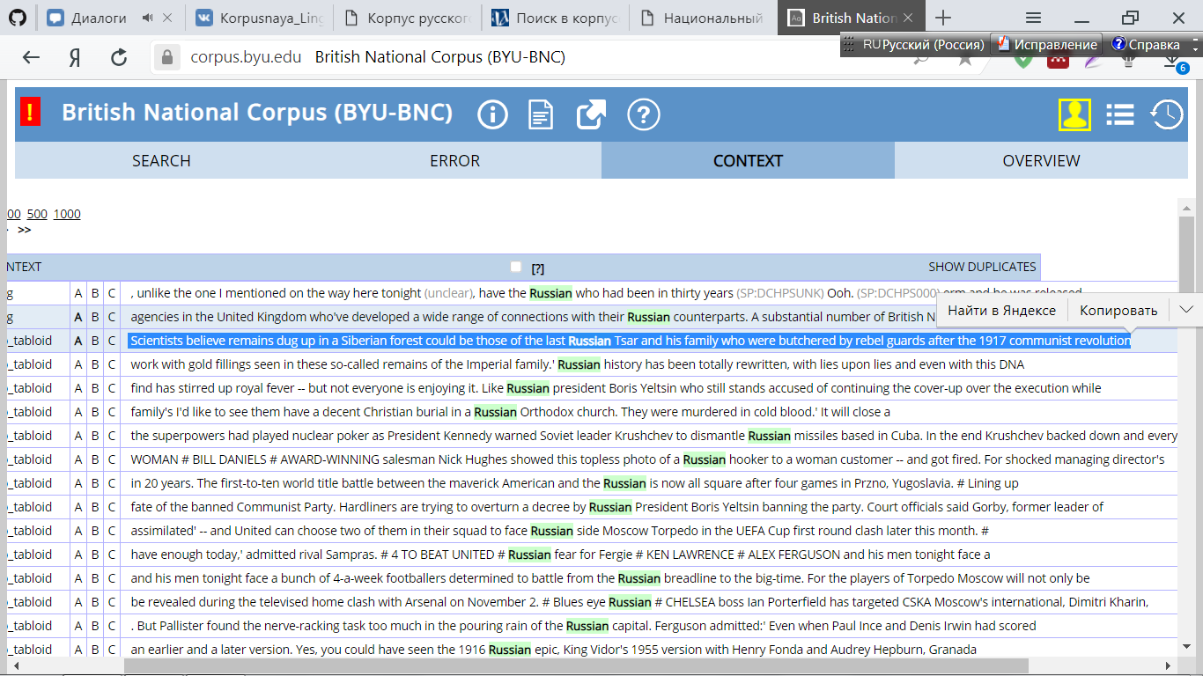

**НКР: Переписка в icq между agd-ardin и Колючий друг (2008.02.08**

|  |
| --- |
| * [agd-ardin, nick] Я не люблю **русский** рок, но эта одна из тех 5-6 групп, которые я слушаю |
|  |
|  |

**Елена Павлова. Вместе мы эту пропасть одолеем! // «Даша», 2004**

|  |
| --- |
| ― А **русский** сделал? Мне учительница сказала, что она тебе двойку в четверти поставит: ты делаешь по три ошибки вслове! |

**Запись LiveJournal (2004)**

|  |
| --- |
| * Моё сознание постепеннно забыло что **русский** ― это мой язык "by default" |

**КРЛЯ:**

**Розов В. В поисках радости // Розов В. С. Собрание сочинений. Т. 1:**

... [Фёдор] #(Леони+ду).# А ка+к ты+ счита+ешь?

[Леонид]. Ви+дишь_ли... по-мо+ему, сто+ит. Ра+ньше бы+л хоро+ший   
**ру+сский** обы+чай -- вы+дел. Жени+лся па+рень в дере+вне -- ему+  
выделя+ют по^л-избы+ и ста+вят глуху+ю сте+ну и^ли даю+т ме+сто для   
постро+йки но+вой... Зна+ешь, ра+зные хара+ктеры, ра+зные ...

**Ерофеев В. Вальпургиева ночь, или Шаги Командора // Восемь**

... по+здно, я+ ду+маю, не нача+ть ли в Росси+и э+ру Просвеще+ния?..

[Гуревич.] Так мы+ её+ уже+ на+чали. Пока+ -- в преде+лах тре+тьей   
пала+ты. А та+м, смо+тришь. . . Ну+, че+м бы+л **ру+сский** наро+д до  
на+с? Вя+лый демони+зм, уны+лое сумасбро+дство. Бесшаба+шность,   
со+тканная из зево+т. Ни+ в ко+м -- никако+го благоро+дия, никако+го ..

**Зуев М. Зелёная зона // Современная драматургия. - 1990. - N 3. - С.**

... Ни+ котле+т, ни+ макаро+н, ни+ рожко+в тебе+ каки+х. Сельма+г   
называ+ется. Одна+ икра+ стои+т, одна+ икра+, и э+ти, ка+к и+х,   
кра+бы. . . Ну+ ра+зве э+то еда+. . . Не+т, не е+л э+ту икру+ **ру+сский**  
челове+к и е+сть никогда+ не бу+дет. Хорошо+, что^ карто+шка е+сть,   
и_то^ сла+ва_бо+гу. Е+сли та+к де+ло пойдё+т, придё+тся в Москву+ ...

**БНК:**

|  |  |  |  |  |
| --- | --- | --- | --- | --- |
| |  |  | | --- | --- | | Date | (1985-1994) | | Title | The Daily Mirror. London: Mirror Group Newspapers, 1992, pp. ??. 9942 s-units. | |

**Expanded context:** who was a first cousin. And Prince Philip's ties are even closer -- his great grandmother was the murdered Tsarina's mother. But despite the excitement among scientists, many historians are not impressed. # Lies British investigative writer Anthony Summers says:' I think we have to be extremely cautious. Hundreds if not thousands of people were shot and buried in the woods where these bones were found.' Among them were rich aristocrats who would have had the same fine dental work with gold fillings seen in these so-called remains of the Imperial family.' **Russian** history has been totally rewritten, with lies upon lies and even with this DNA testing, there is unlikely to be a definite conclusion.' Back in Russia, the find has stirred up royal fever -- but not everyone is enjoying it. Like **Russian** president Boris Yeltsin who still stands accused of continuing the cover-up over the execution while he was a local Communist party boss in the 70s. When the surviving Romanovs asked for the house where the Tsar was killed to be turned into a museum, Yeltsin

|  |  |  |  |  |
| --- | --- | --- | --- | --- |
| |  |  | | --- | --- | | Date | (1985-1994) | | Title | The Daily Mirror. 9610 s-units. | |

**Expanded context:**

.' # HITCH IN TIME: Nick and his bride # Tot takes bomb to show mum # A BOY of three picked up a terrorist car bomb in the street -- and innocently took it home to show his mum and grandma. But as Ryan Cosgrove handed over the oblong box, a red light flashed and it started ticking. His mother immediately dumped the package in her driveway in Protestant West Belfast and called the police. An army bomb disposal expert defused it. A police spokesman said:' The terrorists subjected grandmother, mother and child to **Russian** roulette.' It is thought the bomb was aimed at a member of the security forces. # Deaf drink driver gets message! # A DEAF mute who was stopped by police for erratic driving told a court yesterday that he'd been' chatting' to his passenger in sign language. But he was banned for a year -- because he was well over the alcohol limit at the time. He had been trying to find somewhere to park in London's West End, Keith Hylton told a Marlborough

|  |  |  |  |  |
| --- | --- | --- | --- | --- |
| |  |  | | --- | --- | | Date | (1985-1994) | | Title | The Daily Mirror. 5437 s-units. | |

**Expanded context:**

New Zealand 1 4 5 10 # OUT OF THE FRYING PAN # MIKE LANGLEY # ADIOS, Barcelona -- you old frying pan! Goodbye to your sweaty nights, broiling days, gassy ale and loudspeakers never turned down. Goodbye, also, to the multitudinous managers and coaches of the largest team we've ever sent overseas. That farewell to the coaches was going to be' Hello' until a few minutes ago when the British Olympic Association suddenly cancelled a meet-the-press day. Maybe they had no answer for how a little gymnast from Minsk, training through **Russian** winters in an unheated hall, could win more gold medals on his own than our 388 competitors between them. Six for Vitali Scherbo, but only the usual five for Britain -- and two of those were won in boats and another on a bike! I wondered if the athletics department might explain why we hadn't a 1500 metres runner in the final for the first time since 1960? Would they be suggesting, as some of the swimming coaches did, that kids these days are going soft.

3.

|  |  |  |  |
| --- | --- | --- | --- |
| № примера | РНК | КРЛЯ | БНК |
| 1 | Русский(прилагательное) | Русский (прилагательное) | Russian (прилагательное) |
| 2 | Русский(прилагательное) | Русский (прилагательное) | Russian (прилагательное) |
| 3 | Русский (существительное) | Русский (прилагательное) | Russian (прилагательное) |
|  |  |  |  |

4.

